**30 Day QA Challenge**

# Day 1: Buy a QA Book

I bought “The Phoenix Project.”

# Day 2: Take a photo of something I am doing at work

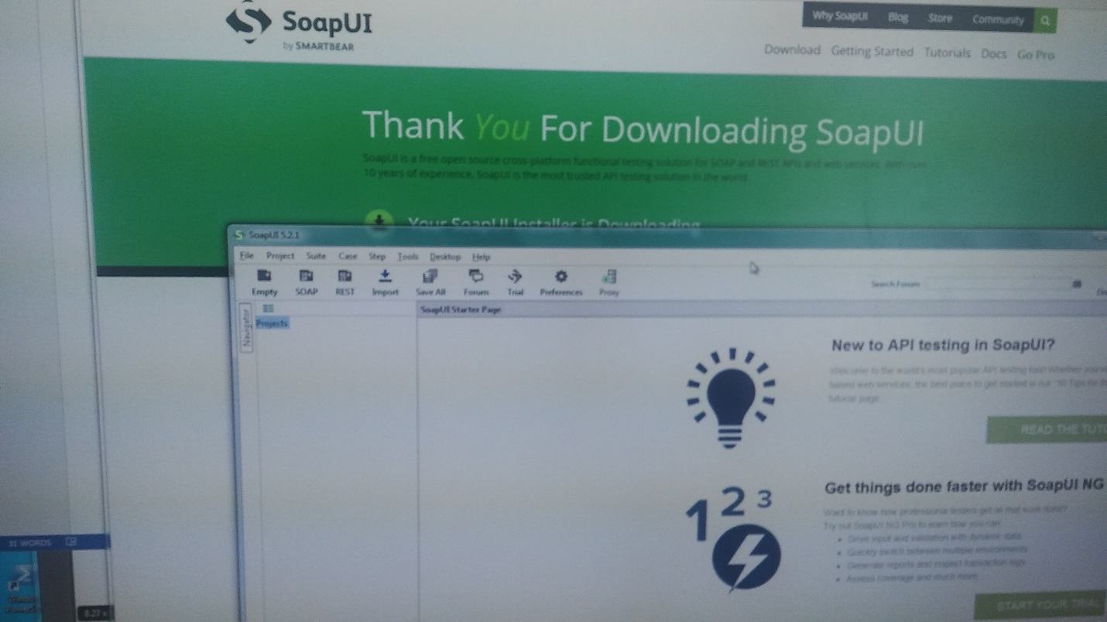

# Day 3: Listen to a Testing Podcast

Downloaded a few episodes from STP Radio podcast. Listened to introduction to STPLive conference, and part of a talk from Mike Lyles, QA Manager at Lowes about testing and the 80’s.

# Day 4: Share a Testing blog with a non-tester

http://www.satisfice.com/blog/

# Day 5: Read a comment on one blog post

# Day 6: Perform a crazy test

# Day 7: Find an accessibility bug

# Day 8: Download a mobile app, find 5 bugs and send the feedback to the creator

# Day 9: Create a Mindmap

# Day 10: Find an Event to attend (online or face-to-face)

# Day 11: Take a picture of the team

Day 12: Doodle a Problem

Day 13: Find a user experience problem

Day 14: Step outside your comfort zone

Day 15: Find a problem with an E-Commerce Website